WEBINAR REPORT
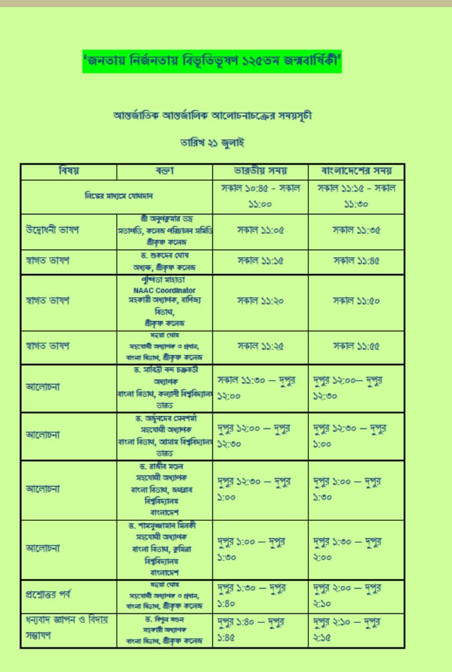
The Department of Bengali, Srikrishna college, Bagula, organized an International Webinar on 125Th Birth Anniversary of famous Bengali novelist Bivutivusan Bandopaddhyay in collaboration with IQAC. The topic of the webinar was “Janotay Nirjonotay Bivutivusan”.This webinar was held on 25th July 2020.Four eminent speakers from India and Bangladesh has delivered their valuable speech on Bivutivusan’s literary work. The speakers were Dr. Sabitri Nanda Chakraborty from Kalyani University,Dr.Arjundeb Sensharma from Assam University, Dr. Rajib Mondal from Jagannath viswabidyalaya ,Bangladesh and Dr.Samsujjama Milky from Kumilla University,Bangladesh.The opening speech was delivered by Mr.Anup kumar Vadra ,President of the Governing Body Of Srikrishna college and welcome speech delivered by the Principal, Dr. Sukdeb Ghosh. About sixty eight participants joined this webinar from different college and university of India and Bangladesh.The Question –answer session ,between the speaker and the audience was very much interesting. All the speakers and participants have enjoyed this webinar in the abnormal pandemic situation.

